

YTP - Module YTP01

Arduino & Micro-Controllers

**Teachers Guide LESSON 1**

**What is Electricity?**

# Goals & Success Factors

### Lesson Goal

* To understand the question “What is Electricity?”
* To have an awareness of different electronic components.
* To understand the question “What is Electricity?”
* To be aware of the necessity of safety when dealing with electricity.

### Lesson Success Factor(s)

* Play the component game
* Watch videos on electricity
* Know what voltage, current and resistance is
* Understand safety aspects of electricity

# Skills Learnt (Arduino Module – Term 1)

**Soft Skills**

Listening to and following instructions

Typing accurately on the keyboard

Working together in pairs and teams

Asking relevant questions

**'Technical' Skills**

Understand electricity and the terms: Voltage, Current & Resistance

Understand the basic difference between digital and analogue

Understand what an Arduino is and what you can use it for

Understand the meaning of a circuit and how it- works

eg. A Single bulb connected to the +ve and -ve terminals of a battery by wires

Understand basic components by recognition and their purpose

- Resistor

- LED (Light Emitting Diode)

- Jumper wire

- Button

- Battery

Understand what a breadboard is, how it works and why we use it

Understand how to build a basic circuit with a breadboard

Understand how to setup a button as an INPUT pin

Understand how to pulldown a pin to 0 volts

Understand how to pullup a pin to 5 volts

Understand how to use the Arduino Application

- How to connect the Arduino to your computer with a USB cable

- How to check the Arduino board

- How to check the port

- How to verify/compile the code

- How to upload the code to your Arduino

- How to create a new application

- What the setup() function does

- What the loop() function does

- How to create a simple variable and set it to a value eg.

// Create an integer variable called myPin and set the

value 2 to it.

int myPin = 2;

- How to set an Arduino pin to either an input OR and output pin

pinMode(2, INPUT);

pinMode(3, OUTPUT);

- How to read a digital pin

digitalRead(2);

- How to write to a digital pin

digitalWrite(2, HIGH)

digitalWrite(2, LOW)

- How to make a decision in code with an 'if' statement

# Runsheet (Guideline)

00:00 Introduction

00:05 Goals & Success Factors

00:10 Ask class about favorite bit of tech

00:15 Play the Component Game

00:30 What is Electricity

00:45 Resistance Demonstration

00:55 Electrical Safety

01:00 Finish

**Extension(s)**

See Student Homework below

# Students Pre-work

N/A

# Teachers Pre-work

N/A

# Student Homework

Watch the following video:

**Voltage, Current and Resistance**: <https://learn.sparkfun.com/tutorials/voltage-current-resistance-and-ohms-law>

Give out handouts specified below (optional)

# Handouts (optional)

Component Guide

Electricity Word search

Safety Guide

Materials Needed

The following components are needed for the component game:

1 x battery

1 x jumper wire

1 x resistor

1 x ceramic capacitor

1 x electrolytic capacitor

1 x LED (Light Emitting Diode)

1 x switch

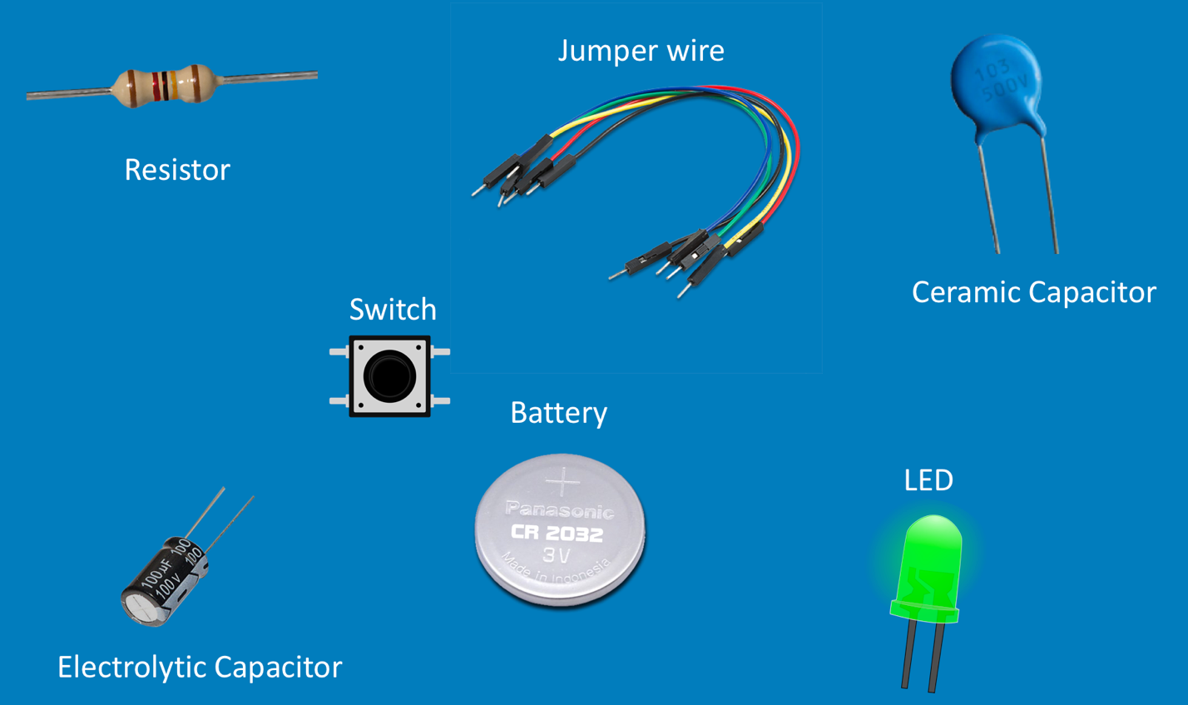

# Main Content

## Definitions

### Electricity

Electricity is energy resulting from the movement of charged particles (e.g. electrons or protons). Electricity could be static or electric but for the purposes of this module, we are interested in electric current as opposed to the movement of statically charged particles.

Electricity is typically made up from 3 components, voltage, current and resistance. Given that we know the value of two of these components, we can work out the third because there is a linear relationship between the 3 things. The equation that we use to work out voltage, for example is:

V = IR

V = voltage (in Volts)

I = current (in Amps)

R = resistance (in Ohms)

### Voltage

The voltage (as seen on a household battery) is the difference or measurement in charge between two points – for example the positive and negative terminals of a battery. Voltage determines the force of the flow of current through a circuit.

### Current

Current is the flow of electrical charge (usually electrons). The common symbol (as above) for current is I and the unit of measurement is Amps (A). One amp represents one coulomb of electrical charge – that is 6.24 billion billion charge carriers (approx.) moving past a point in one second (the charge carriers are electrons).

### Resistance

Resistance is the third part of the electricity equation. Every material offers up some sort of opposition to current flow within it. This is called resistance and is represented by the letter R. It is measured in Ohms (Ω)

Watch the following videos on this webpage for an excellent introduction to electricity:

<https://learn.sparkfun.com/tutorials/voltage-current-resistance-and-ohms-law>

## Introduction to Electronic Components

We will be using a handful of the most common electronic components for this module. These are components you will find in every single household device. By the end of the module, students will understand the what these are and why we might use them:

### Resistor

‘Resists’ or impedes the flow of current through a material or circuit.



### Capacitor

A component that stores energy. It can almost be viewed as a temporary battery.



### Switch

The switches we will use are momentary switches. They are in the ‘on’ position for as long as their button is pushed down. When released they are in the ‘off’ position.



### Breadboard

A breadboard is a set of conductive metal strips that make it easy to prototype circuits very fast compared to the process of manufacturing a circuit board.

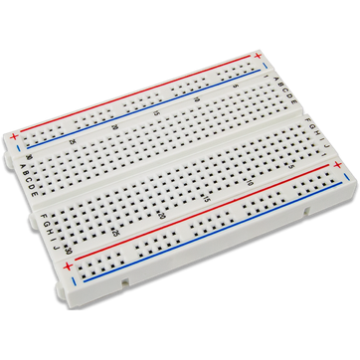

### Battery

A battery is an ‘energised’ component used to power a circuit/appliance/device… etc. Batteries have a voltage which defines the difference in charge between the positive and negative terminals.



### Jumper Wire

Jumper wires are used to make connections between components.



### LED (Light Emitting Diode)

LEDs allow current to flow one way only. They have 2 legs, one of which is longer than the other. This leg is the one that must receive the current first and is the positive leg. If an LED is plugged in the wrong way, current will not flow through it. LEDs can be white, red, green, yellow, blue… There are even ones that can emit any colour.



## Electrical Safety

Whenever you start any project involving electricity, you need to be aware of safety issues and constraints. Whilst we are NOT dealing with high voltages and currents which would be dangerous, we can still potentially set things on fire !! As we are working with simple circuits and low currents/voltages, the guidelines are simpler and not as stringent. So to that end:

1. Never connect the ends of a battery together
2. When coming into the classroom, DO NOT touch ANY components laid out on the table/desk
3. Listen to the Instructor so that you know what to do with each components
4. Components and cables are NOT toys. Do not play with them in ANY way
5. Do NOT plug in your circuit/Arduino before being told to
6. Never plug in your circuit/Arduino until your circuit has been completely built.
7. ALWAYS get an adult to check your work/circuit before plugging in.

Electricity Handouts

Handouts are optional but encouraged. They are normally useful for homework but in some cases you may deem them useful for pre-work depending on the upcoming session content. The handouts are shown here but are alternatively available for download at:

https://github.com/nexgencodecamp/ytp/tree/master/modules/arduino/01-electricity



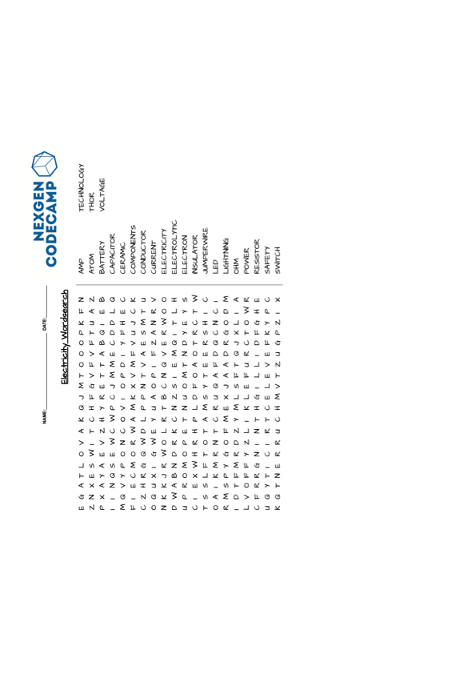



## Resources

Introduction to Electricity

<https://learn.sparkfun.com/tutorials/voltage-current-resistance-and-ohms-law>

Electronics (Definitions of terms)

<https://whatis.techtarget.com/glossary/Electronics>